**Setup Document**



**Course:** Project P-Phase

**Group :** Open Core

**Members of Group:**

* Preslav gerchev
* Stanislav staev
* Blagovest tsarev
* Dimitar Vikentiev

**Couch:** Emin Thaqi

Date: 31.03.2015

1. Preface 3

2. Client 3

3. Processes 4

4. Functional requirements 11

5. User interface 12

1. Preface

This document is about explaining some of the things will be doing during this event. We from the Open Core team will assist our client to develop a social event. Which features creating a website design, multiple applications and a database.

1. **Client**

Mr. Emin Thaqi is an ICT teacher for Fontys , moslty in database . Wants to arrange a social event and has hired us to create the system for this event.

1. Processes

Process1: Entering

Precondition:

Prepare the scanning machines and application.

Description: Customers are entering the event, the staffs will check their tickets.

Steps:

1. Customers come to the entrance and show their ticket.
2. Staffs scan the ticket id
3. We give the customer a bracelet.
4. Customers can go inside.

Exceptions:

1. Customers don’t have ticket.

Solution: Customers will go to ticket office to buy tickets.

Post-condition:

Customers can go inside and attend the event.

Process2: Purchasing tickets online.

Precondition:

Prepare the website.

Description: Customers want to buy tickets from the website.

Steps:

1. Customers go on the website and press “buy ticket”.
2. Customers register on the website.
3. Customers pay the expenses by PayPal.
4. Customers gets printable ticket on his email.

Exceptions:

1. No tickets left.

Solution: Customers can’t attend the event.

Post-condition:

Customers want to attend the event.

Process3: Purchasing food & drinks

Precondition:

Prepare the scanning machines and application.

Description:

Customers are buying food & drinks.

Steps:

1. Customers go into a shop and pick the goods.
2. Customers go to cashier desk.
3. Shopkeepers use the application.
4. Shopkeepers deduct the balance.

Exceptions:

1. Customers don’t have enough balance to purchase.

Solution: Customers has to add money to his balance.

1. Run out of products

Solution: Staffs will have to replenish.

Process4: Rent Equipment

Precondition:

Prepare the scanning machines and application.

Description: A customer rents something.

Steps:

1. Customer goes to the rent booth.
2. Shopkeepers use the application to assign an item.
3. Customer takes the item.

Exceptions:

Post-condition:

The customer can keep the item until the end of the event and has to take care of it.

Process5: Rent a tent

Precondition: Prepare the scanning machines and application.

Description:

Customers can rent a tent at camp office.

Steps:

1. Customers come to camping place.
2. Our staff scans the bracelet.
3. Customers pay the rent expenses.

Exceptions:

1. Customers don’t have enough balance.

Solution: Customers have to add balance.

1. Don’t have enough tents.

Process6: Return equipment

Precondition:

Prepare the application

Description: Customers want to return the things they rented.

Steps:

1. Customers come to rent shop and return the item.
2. Shopkeepers use the application to interact with the database.
3. Customer pays the rent
4. Shopkeepers get items.

Exceptions:

1. Equipment is damaged

Solution: Customers will pay extra .

1. Customer don’t have enough balance to pay the deposit.

Solution: Customer will have to add more to his balance.

Process7: Checking out

Precondition:

Prepare the application.

Description: Customers want to exit.

Steps:

1. Customers come to exit and show the bracelet.
2. Staffs use the application to check for hired items.
3. Customers can go outside.

Post-condition:

Customers can go outside and leave.

4.Functional requirements

* MUST:
  + The applications must be connected to website and database.
  + Application must be able to recognize the bracelet.
  + Application must be able to update the database.
  + Application must be able to add money to customers’ balance
  + Participants must receive their refund back after leaving the event.
* Should:
  + Application should be user-friendly.
  + Application should be simply displayed (to avoid confusion).
* Could be
  + Applications could have for example a map of the event.
  + Applications could be designed based on the theme of the event.
* Not be
  + Applications will not be used by customers.
  + Applications will not be able to be used on phones or tablets

5.User interface

5.1 Entrance application

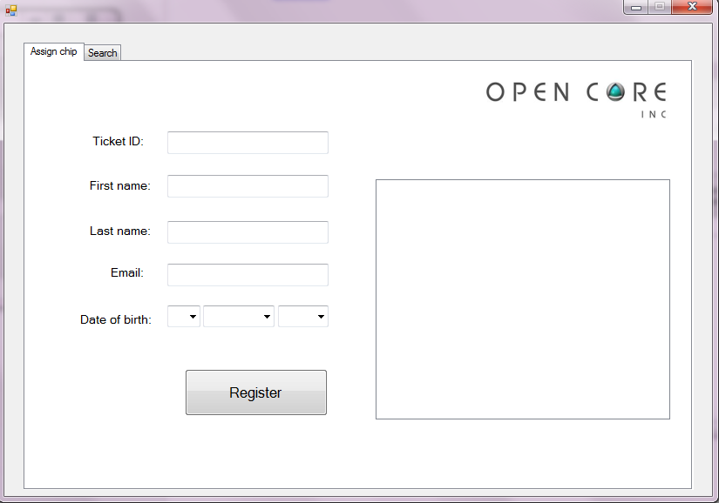

This tab of the application is used to register a new person or assign a bracelet to an already existing one. The list box on the right will be used to show information about the person , if he/she register successfully.

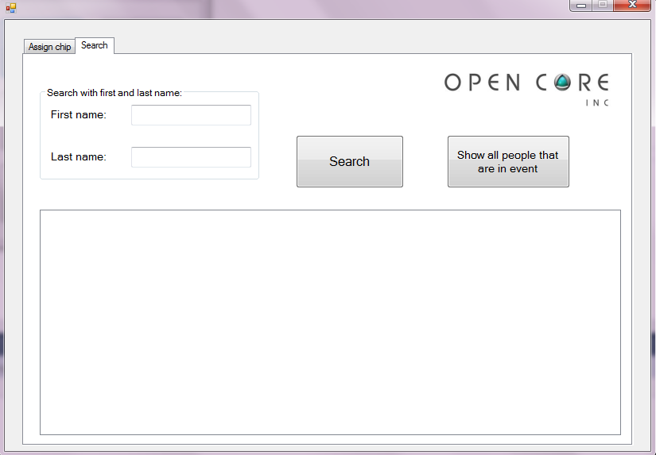

The search button will be used to provide information about the person or people with the given first and last name , displayed in the two text boxes. The Show all people button is used to display a list of all the people registered and extra information about them such as last check in / check out and current status.

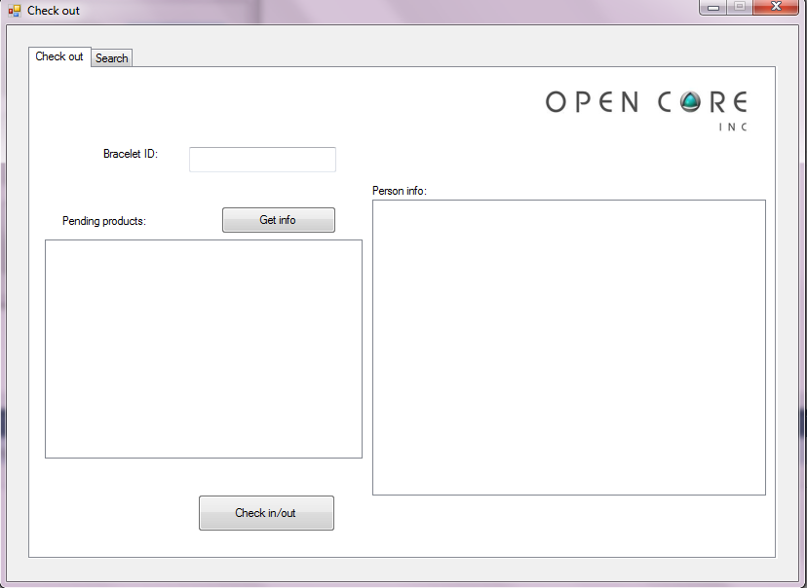5.2 Check out application

When a person wants to exit the event , he will be asked to scan his bracelet , the left list box will display any items he still has to return and if there are any, he will not be allowed to leave the event , unless he returns them. If there are no items he will automatically checked out . The two buttons are used in case the scanner doesn’t work.The list box on the right displays the person’s info , when checked out.

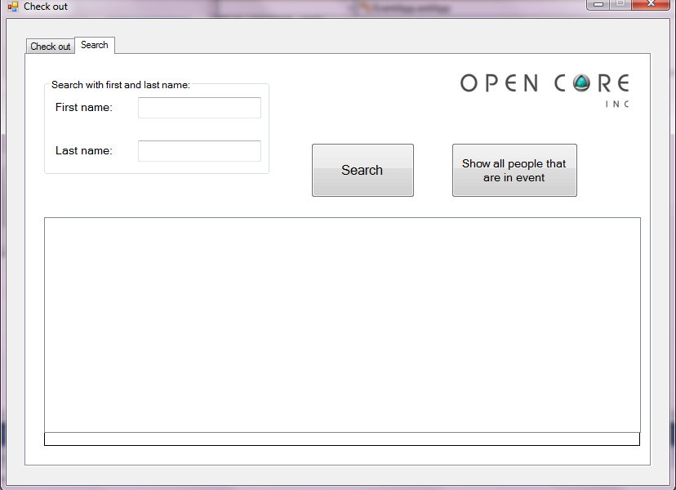

The search button will be used to provide information about the person or people with the given first and last name , displayed in the two text boxes. The Show all people button is used to display a list of all the people registered and extra information about them such as last check in / check out and current status.

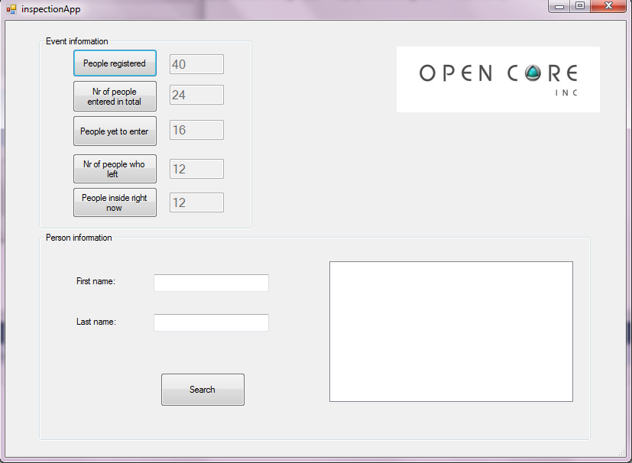5.3 Inspection application

When started the application will automatically provide the user with the information shown on the screenshot above. There is a timer that refreshes this information every 30 seconds , or you can click one of the buttons to refresh it immediately. The search button will provide information on the right for the person searched.

5.4 Hired application 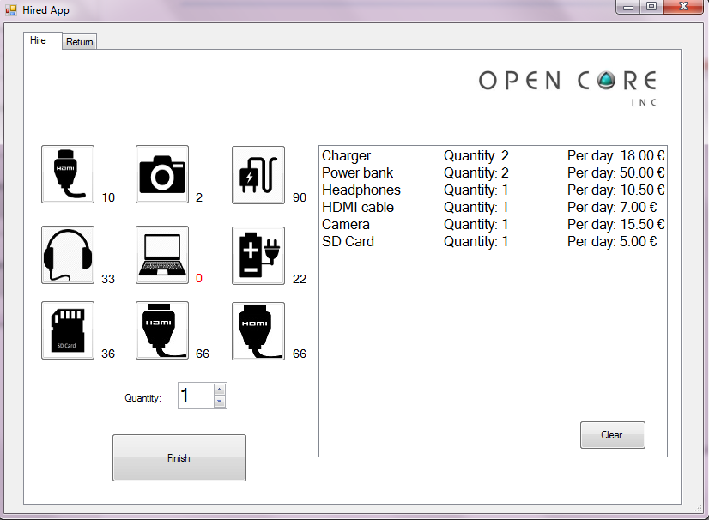

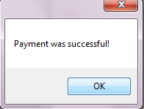This tab is used to hire equipment , you can see the quantity of the remaining products on their right and you can use the quantity box to hire more than one equipment item. The list box displays you order so far and gives the price per day of the hired equipment. The finish button will provide the user with a text box , where he can scan his bracelet and hire the items. If everything is ok he will receive a confirmation .

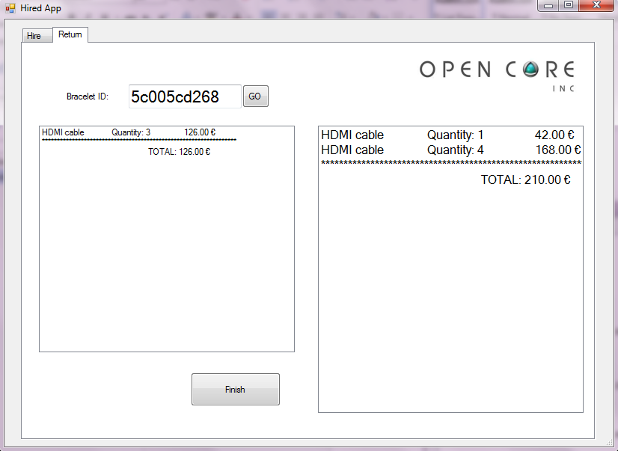

This tab provides the user with the option to return his hired equipment . On the right you can see all the items he has hired so far. By double clicking on one of them he can put it on the left list box , which displays items that will be returned. This means that you can return specific items now and the rest later. The finish button provides the use with a text box to scan his bracelet and to make a payment towards our bank account, if everything is ok he will receive a confirmation , if he doesn’t have enough money the items will not be returned.

5.5 Shop application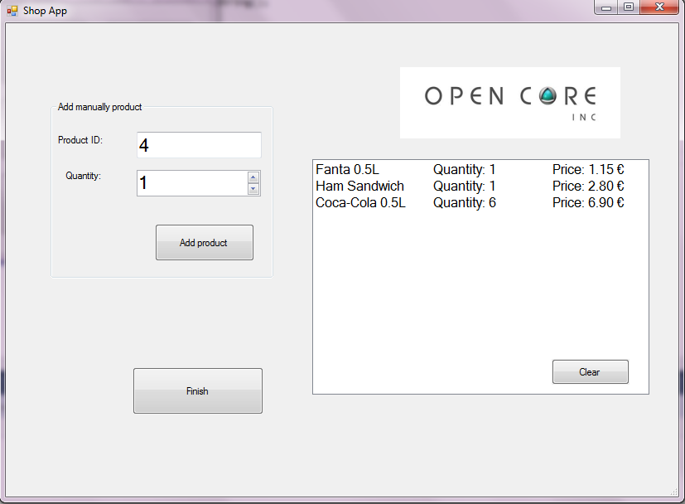

This application is used to buy food and drinks from our shops inside the event. The scanner scans the product and you can assign quantity. The product ID text box is used in case the scanner doesn’t work. The finish button provides the user with a text box to scan his bracelet and make a payment. If everything goes ok the user will receive a confirmation for the payment.